The Android app development made use of 2 major developer tools:

1. Tensorflow lite

2. Android Studio

Below is the detailed description of how anyone can develop this app. Steps to develop the image classification app :

1. **Step 1** is preparing the dataset , select atleast 20 images of as many classes of object you want to classify then put then in different folders and your customised dataset is prepared.

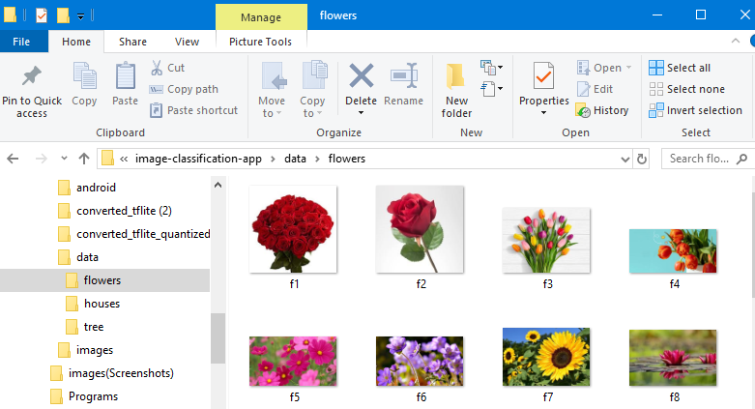

**Step 2** is to go to the machine learning techables link (https://teachablemachine.withgoogle.com) this is sponsered by google and provides a simple GUI way to create our ML models without the need to writting the code next select image project and add your dataset folders as different classes into it .

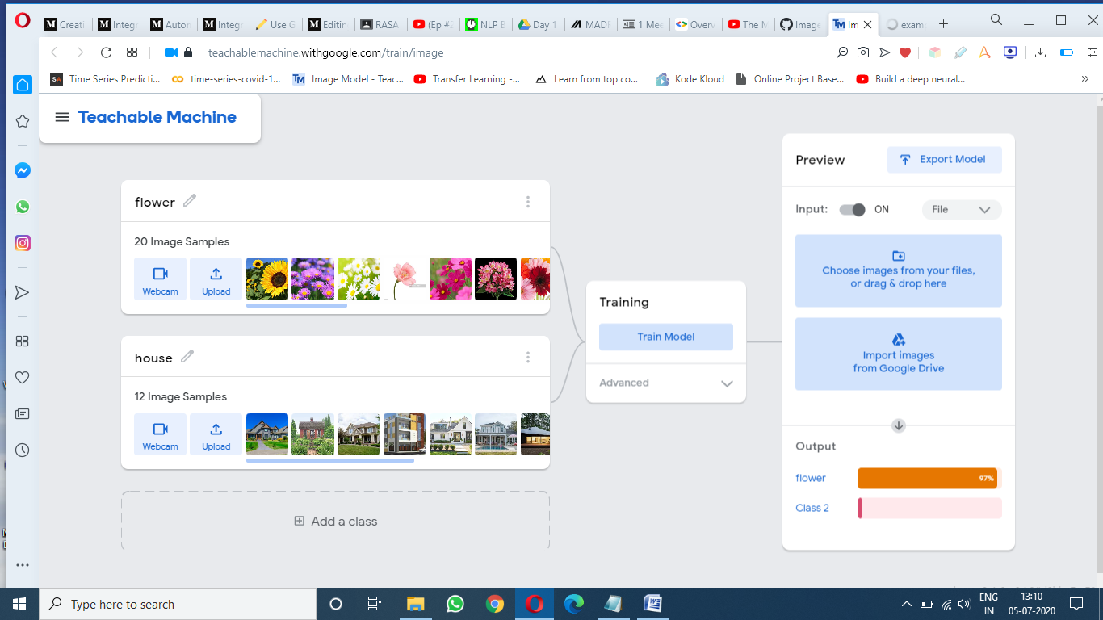

3. Step 3 is to train the machine and wait for it to show the preview of the model. then select export model and of the 3 options provided select Tensorflow Lite and select Floating point and Quantized and download the model. 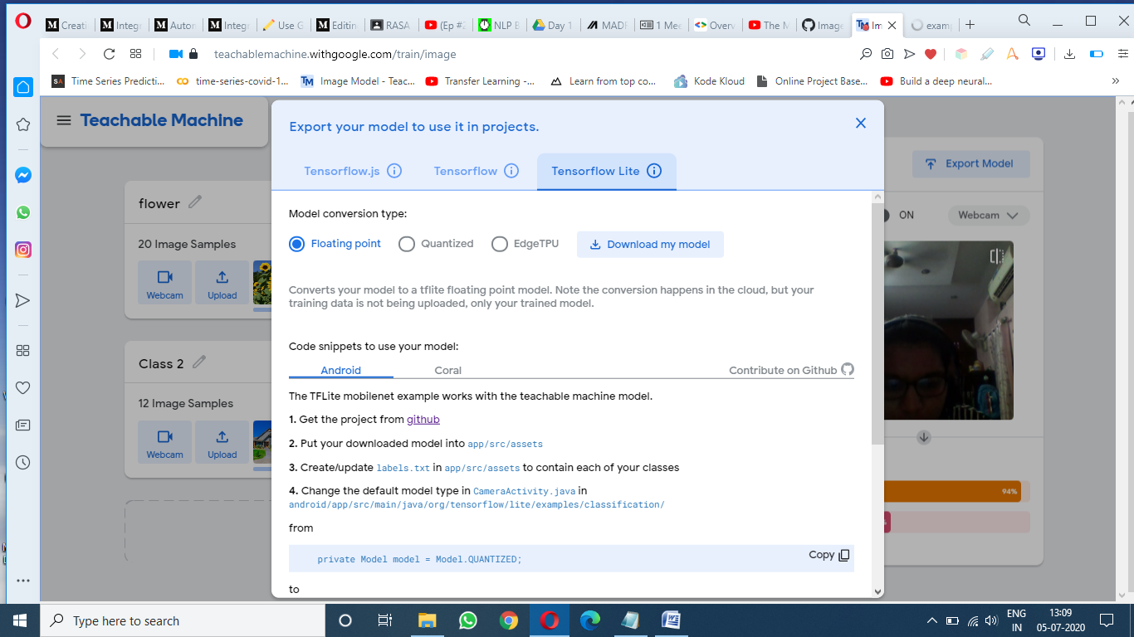

4. Step 4 Now to get the Android code from Github click on this link (<https://github.com/tensorflow/examples/tree/master/lite/examples/image_classification/android>)And clone the app style you want. 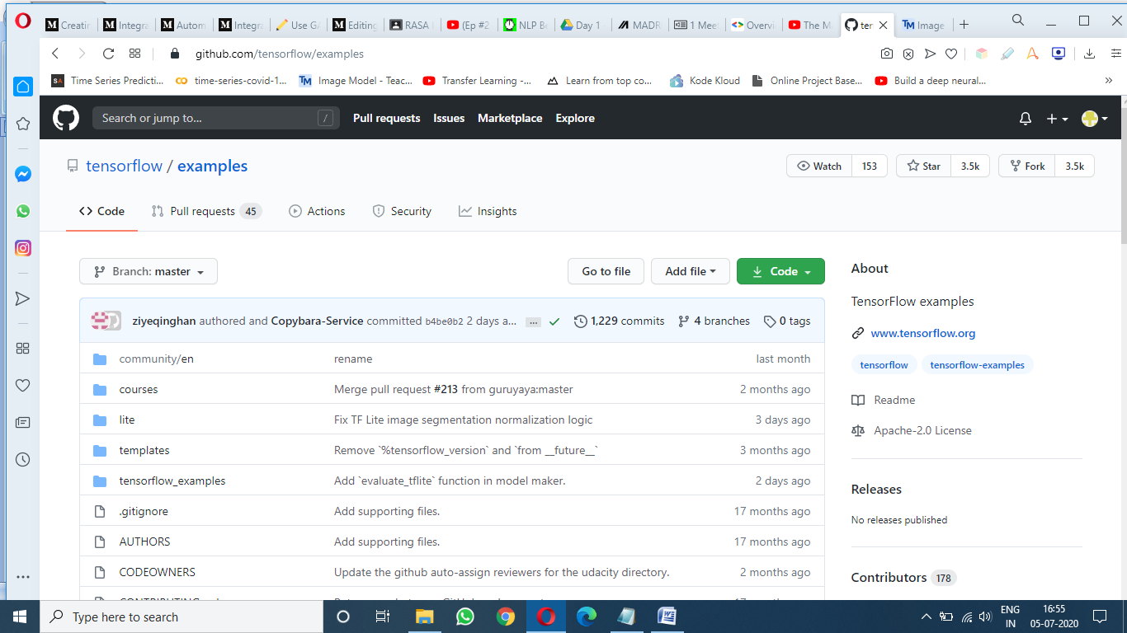

Step 5 : got to this location [**examples**](https://github.com/tensorflow/examples)**/**[**lite**](https://github.com/tensorflow/examples/tree/master/lite)**/**[**examples**](https://github.com/tensorflow/examples/tree/master/lite/examples)**/**[**image_classification**](https://github.com/tensorflow/examples/tree/master/lite/examples/image_classification)**/**[**android**](https://github.com/tensorflow/examples/tree/master/lite/examples/image_classification/android)**/**[**app**](https://github.com/tensorflow/examples/tree/master/lite/examples/image_classification/android/app)**/**[**src**](https://github.com/tensorflow/examples/tree/master/lite/examples/image_classification/android/app/src)**/**[**main**](https://github.com/tensorflow/examples/tree/master/lite/examples/image_classification/android/app/src/main)**/assets/** and

Add Labels.txt file, model.tflite, model_unquant.tflite files from the model downloaded.

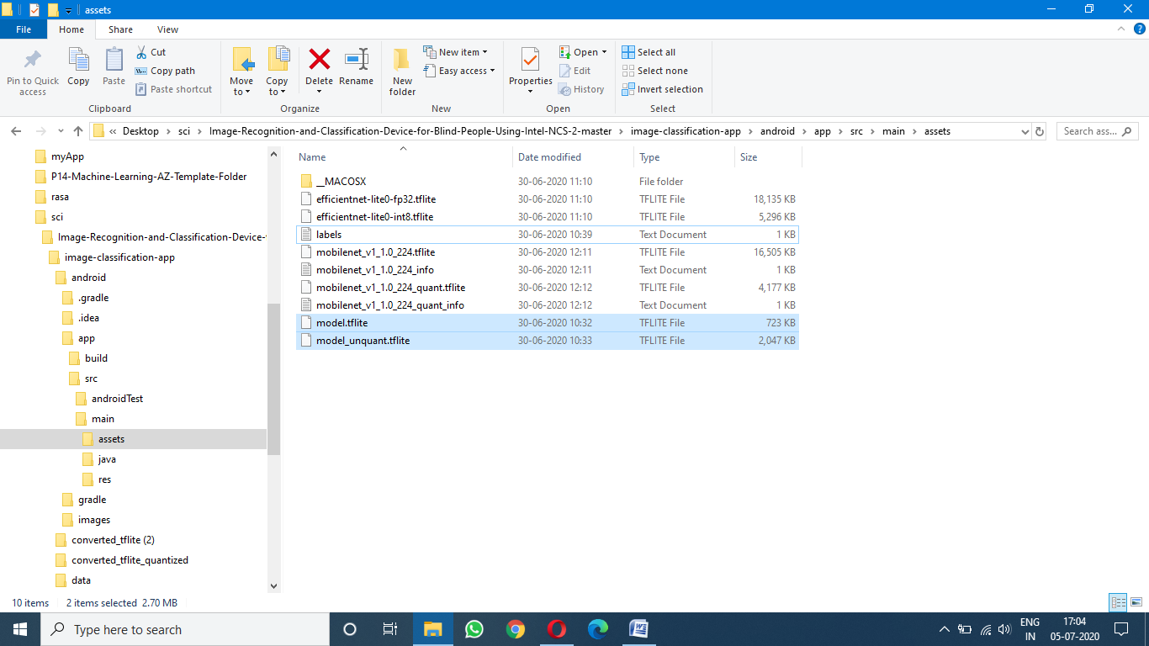

Step 6 align the lables in the lables.txt file in the following format : 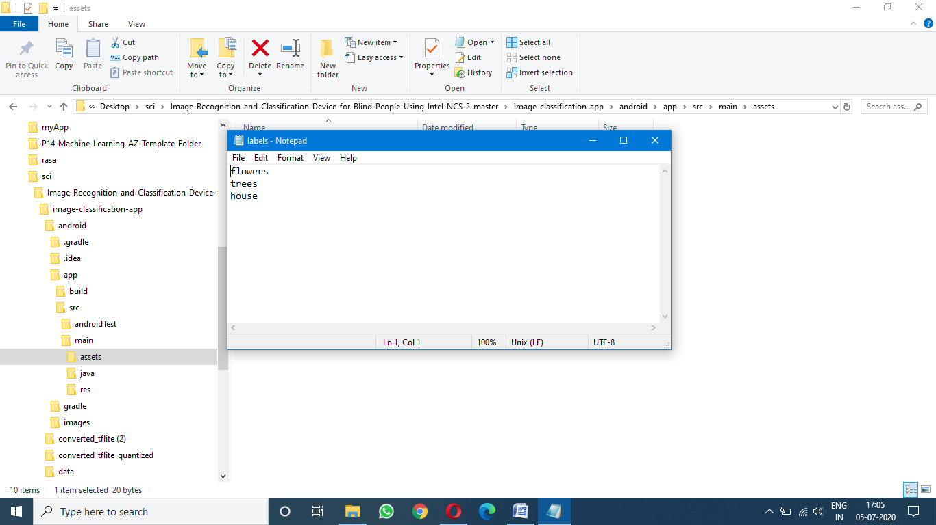

Step 7 open the app code in android studio and on the 101th line of CameraActivity file change return value to MODEL.FLOAT_EFFICIENT. 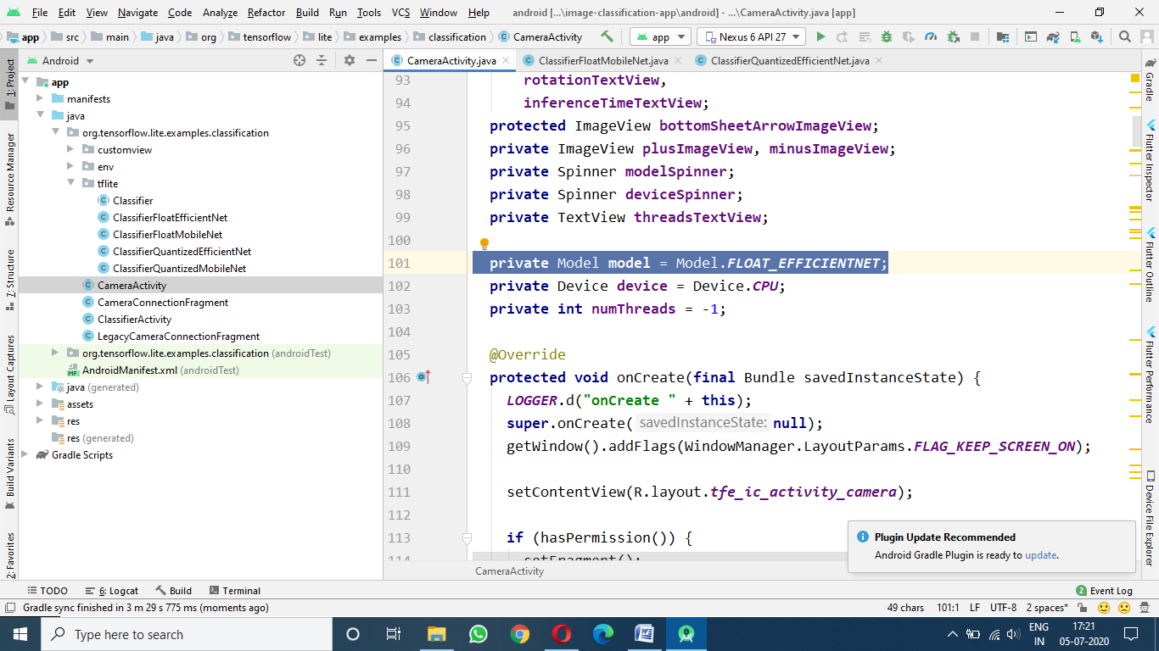

In CLASSIFIER FLOAT MOBILENET file on line 55 change the return value to ‘model_unquant.tflite’ 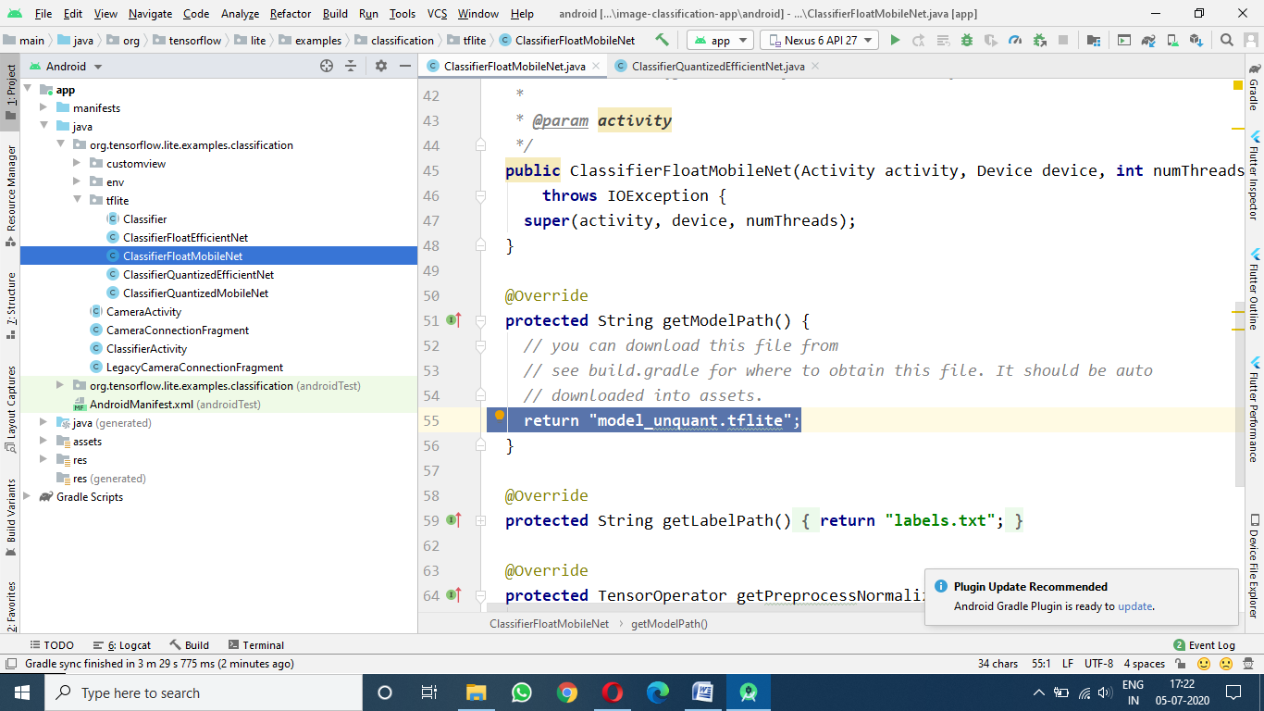

In CLASSIFIER.FLOAT_EFFICIENT file line 53 return value to ‘model_unquant.tflite’ and return lables.txt on line 57.

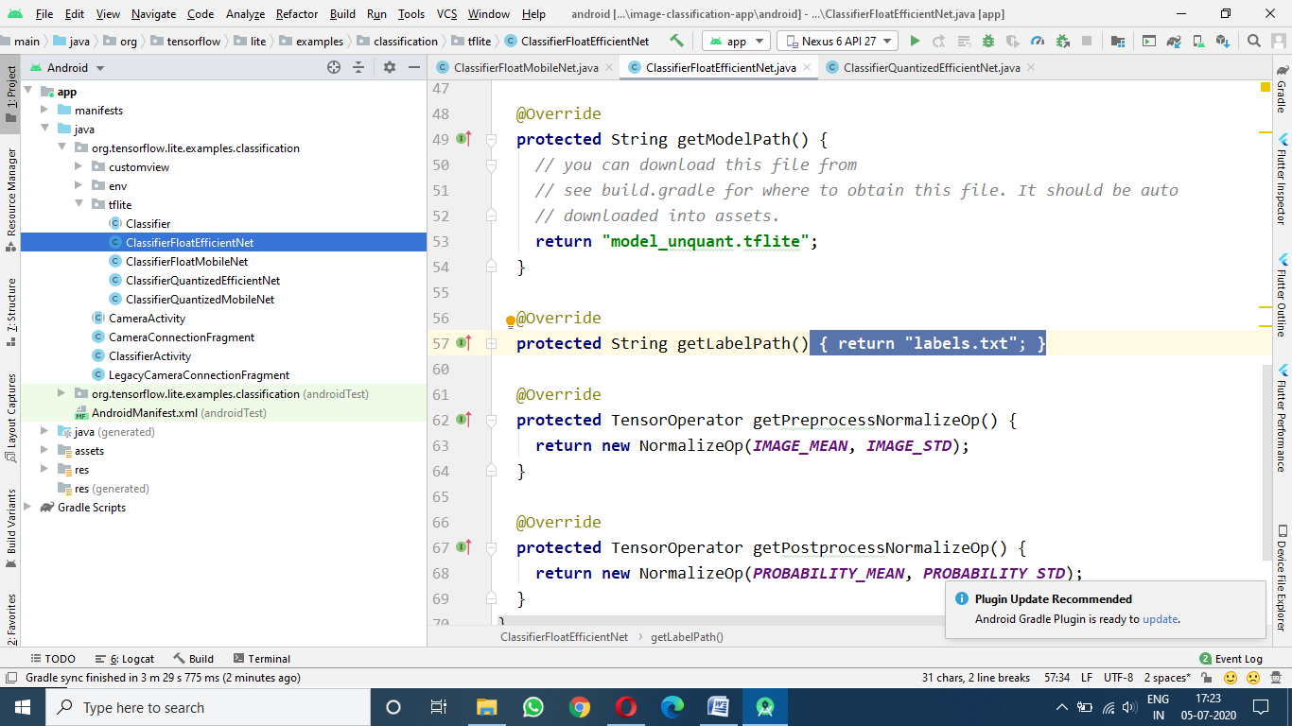

In files ClassifierQuantizedMobileNet and ClassifierQuantizedEfficientNet change the return values to ‘model.tflite’ 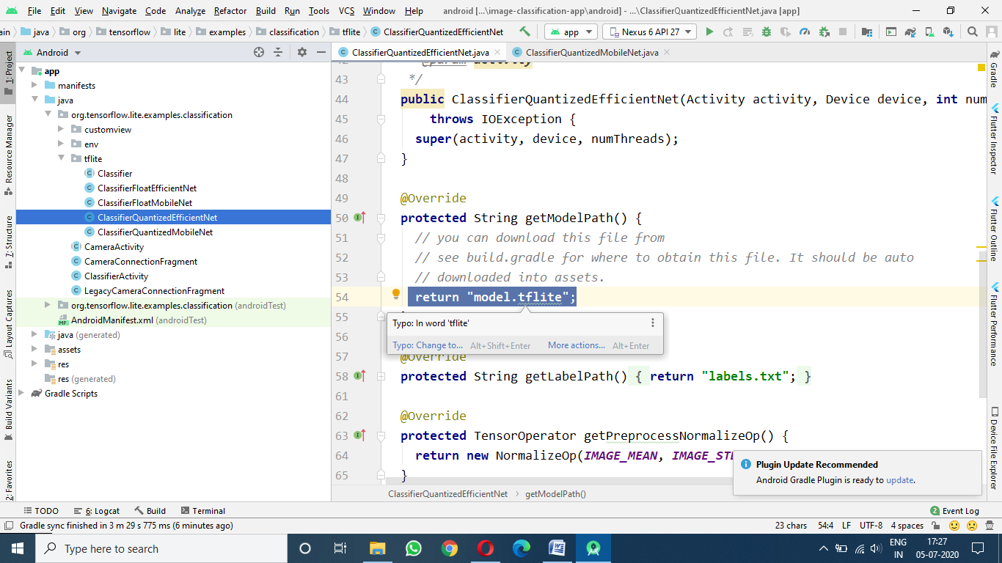 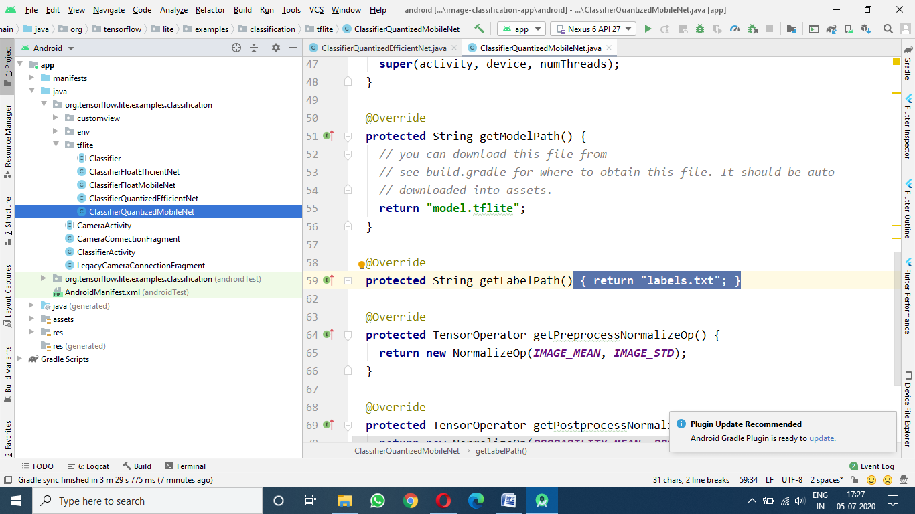

This completes our task now either use a simulator or you own phone to run the app and try it with different images and test the accuracy of your model. Here is the screenshorts of my result

